You put the text for your story here…you move the boxes around or resize to fit the desired look and feel of your story presentation.

You can change the shape by clicking insert and click on “shapes.”

Always check if you have the right font style…be nice to be consistent with the styling of your document.

You can double click on the box to change, Shape Outline size and colour or change the fill colour depending on your preference.



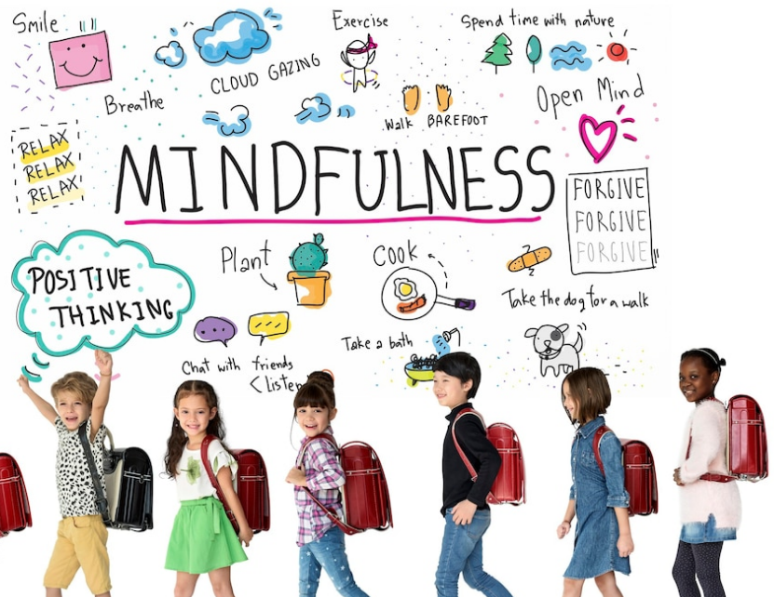



**Title of the learning story**

**Name of** Child: Age: Teacher:

Date: